CSE 5349/6392

Project Report

Title: **Gesture Controlled Drone**

**Team Members:**

|  |  |
| --- | --- |
| **NAME** | **STUDENT ID** |
| Alekhya Joga | 1001959491 |
| Gaurav Chajjed Mahaveer | 1001861652 |
| Vijit Singh | 1001238476 |

**Introduction:**

**What is Drone?**

An unmanned aircraft is a drone. Unmanned aerial vehicles (UAVs) or unmanned aircraft systems are more official names for drones. A drone is essentially a flying robot that can be remotely controlled or fly on its own using flight plans that are controlled by software and onboard sensors and a global positioning system (GPS).

UAVs were frequently linked to the military. They were first employed as platforms for weapons, which was more contentious, anti-aircraft target practice, and intelligence collection.

**What is Gesture Control?**

**Gesture control** is the ability to recognize and interpret movements of the human body in order to interact with and control a computer system without direct physical contact.

______________________________________________________________________________

**Functionalities:**

* The goal of this project is to enable gesture control of a Tello drone.
* This will be achieved using a gyroscope, accelerometer, magnetometer, raspberry pi, and Tello drone.
* The drone will function based on the gesture of the sensor that will be in the user’s hand.

______________________________________________________________________________

**Components List:**

**BNO055 sensor:**

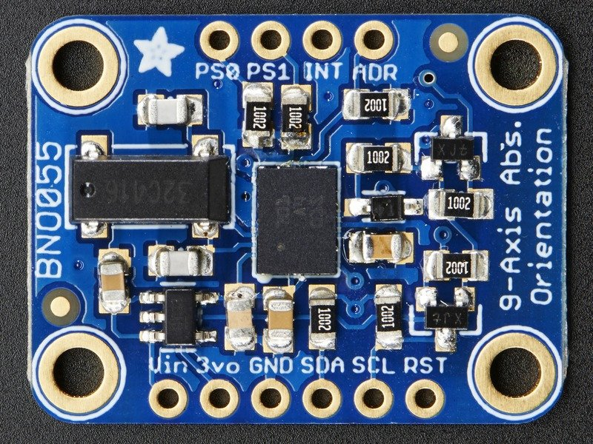

* BNO055 uses three triple-axis sensors to simultaneously measure tangential acceleration (via an accelerometer), rotational acceleration (via a gyroscope), and the strength of the local magnetic field (via a magnetometer).
* Data can then be either sent to an external microprocessor or analyzed inside the sensor with an M0+ microprocessor running a proprietary fusion algorithm.
* Users then have the option of requesting data from the sensor in a variety of formats.
* The chip also has an interrupt that can notify the host microcontroller when certain motion has occurred (change in orientation, sudden accelaration, etc.).

**Tello Drone:**

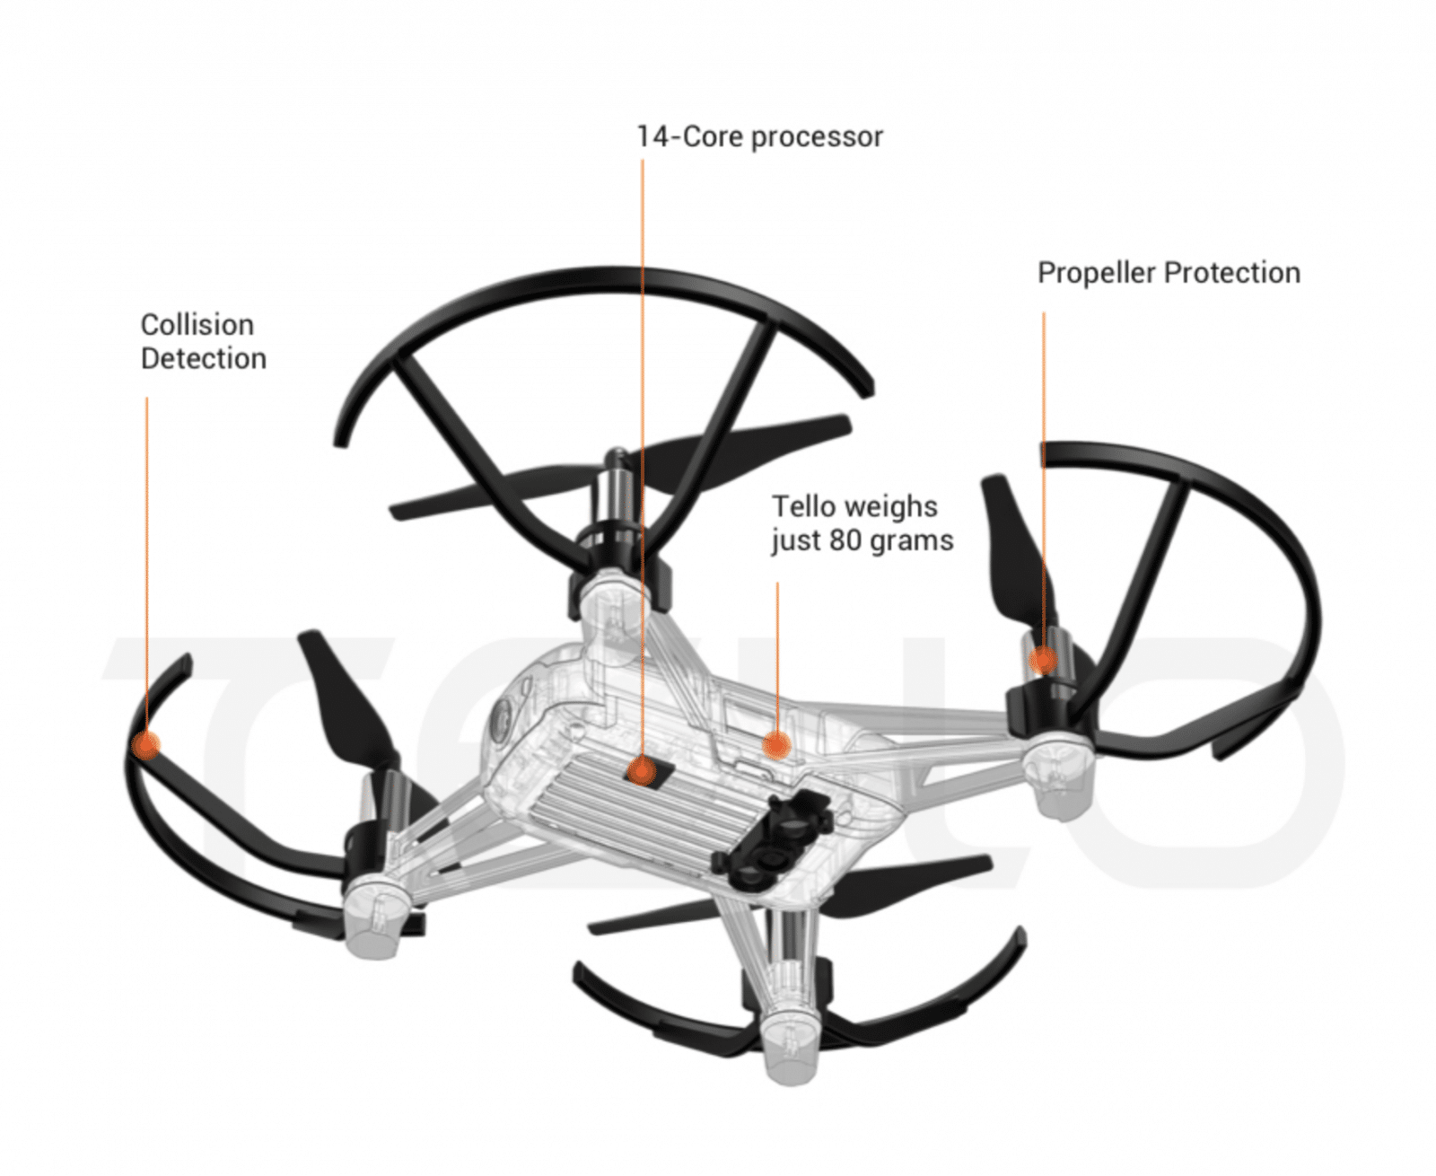

* An indoor quadcopter that comes equipped with an HD camera, giving you a bird’s-eye view of the world and easy to fly.

## **Notable Features of Tello Drone**

* Tello has sensors that assist it in navigating obstacles and landing.
* iOS or Android smartphone with the application is used to control the DJI Tello.
* The 13-minute flight time of the DJI Tello is great. S uitable for your indoor testing!
* A 5MP camera is included. It features digital image stabilization and can record videos in 720p!
* Weighs around 80 g (Propellers and Battery Included).
* You can use the Bluetooth controller or your smartphone to control this little drone in a variety of flying modes, and its maximum flight distance is 100 meters.
* It includes two antennas for extremely steady video transmission and a large battery for astonishingly long flight periods.
* It includes a Micro USB Charging Port.
* Tello has sensors that assist it in navigating obstacles and landing.

**Raspberry Pi 3B+:**

**

* The newest Raspberry Pi 3 model, the Model B+, features a 64-bit quad-core processor running at 1.4GHz, dual-band 2.4GHz and 5GHz wireless LAN, Bluetooth 4.2/BLE, faster Ethernet, and PoE functionality through a separate PoE HAT.
* The modular compliance certification for the dual-band wireless LAN enables the board to be incorporated into finished products with much less wireless LAN compliance testing, reducing both the cost and time.

**Implementation :**

* We are using the BNO055 sensor and connecting it to the raspberry pi. The pi is accessed by the user using a PC.
* The sensor as mentioned above has an accelerometer, gyroscope and magnetometer which will assist the user in capturing the following – acceleration, temperature, Euler’s angle etc.. of the sensor at that point.
* We use these attribute values and write python code in such a way that helps the Tello drone to move up, down, left right, clockwise and anticlockwise.
* We then connect the Tello Drone to the raspberry pi using the drone’s wireless network.
* Once the pi along with the sensor is integrated with the drone and connected on the same network, we run the python code that initiates the drones movement.
* Since the raspberry pi is hardwired to the sensor. The signals are captured at any particular position of the drone according the the drones movement which is again controlled by the user.

________________________________________________________________________

**Prototype :**

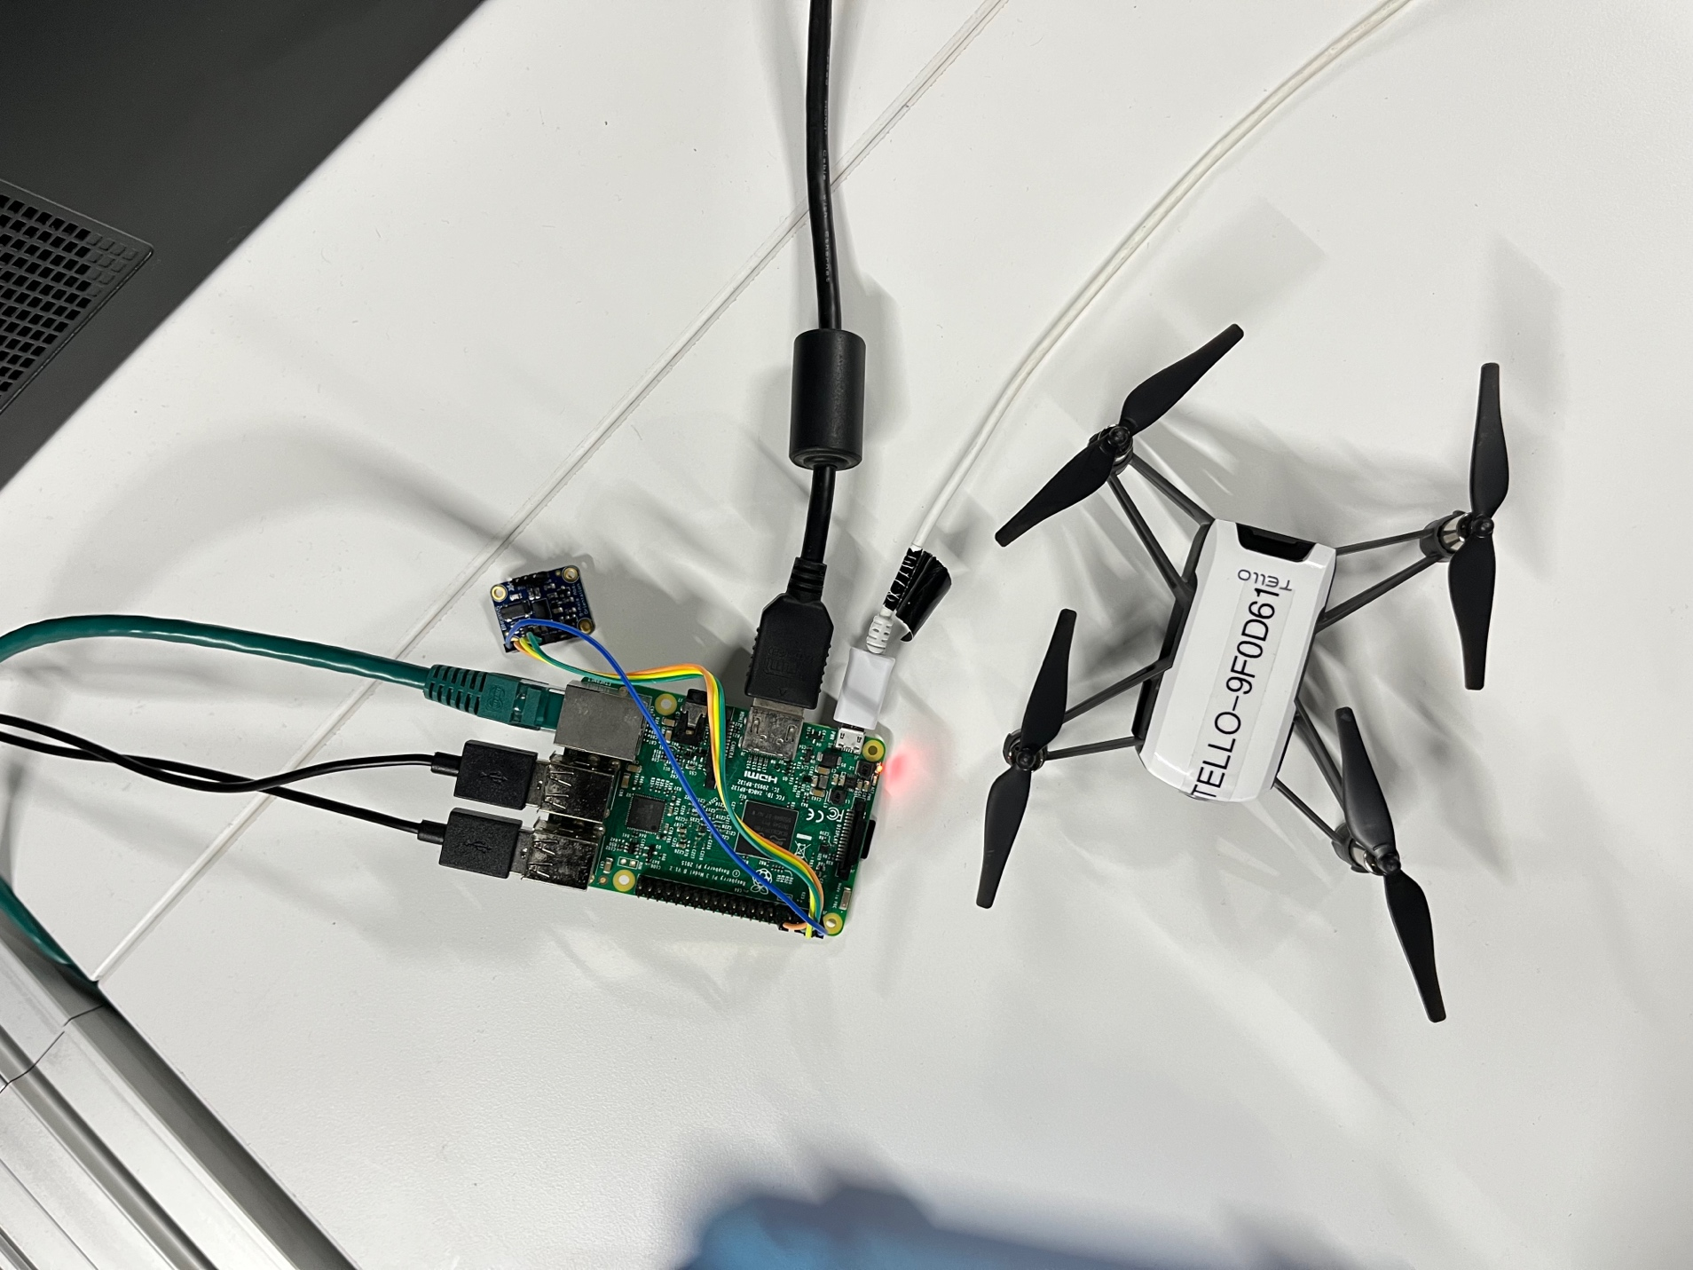

**Working Environment:**

* The hardware we will be using is the BNO055, a Raspberry Pi Model 3B+, DJI Tello drone, and jumper cables. The BNO055 contains 3 sensors: a gyroscope, an accelerometer, and a magnetometer. On the Raspberry Pi, we will be using the GPIO connector, the basic computational components, and the on-board WiFi. Finally, we will use an OEM Tello drone.
* The software we will be using will include Python and the DJI APIs. With Python we will read sensor data from the GPIO and interface with the drone using the DJI Tello APIs over WiFi. We plan to use the PyCharm IDE for development on Raspbian OS.

**Scheduling teamwork:**

The team has worked on the project together at every step. We connected regularly via teams call for tracking our progress and met in person to develop the prototype model of the project.

|  |  |
| --- | --- |
| **Task** | **Due** |
| Configuring Raspberry Pi | Vijit |
| Read and interpret Sensor Data over GPIO | Vijit and Alekhya |
| Control Drone using DJI APIs over WiFi | Gaurav |
| Integration of the drone with the raspberry pi | Gaurav |
| Documentation | Alekhya |

**GitHub Link:**

<https://github.com/VijitSingh97/Gesture-Controlled-Drone>

______________________________________________________________________________

**YouTube Channel:**

[**https://youtu.be/9smB7knkcLo**](https://youtu.be/9smB7knkcLo)

**______________________________________________________________________________**

**Lessons Learnt :**

* The existing controls are difficult to use and not intuitive.
* Libraries for devices can be depreciated.
* Host systems are not always supported for the libraries available. BNO055 sensor for example, had more support for Arduino and beagle bone devices.
* Drones have limited range and features.
* Limited to APIs supported by drone.
* Newest versions of Linux have limited backwards compatibility with required dependencies libraries, legacy drives and used libraries.
* Soldering is not as easy as it looks and takes quite a bit of patience and skill.
* Learnt how to calibrate the sensor.

**Advantages of the system :**

* Use case filming with a drone is easier.
* More user integration could increase the popularity of drones and help reduce skill gap.
* Sensors for controller are cheaper and not as heavy as a micro controller.
* Drone movement is highly customizable and especially helpful for special needs members.
* Integration with smarter control algorithms can provide built in routes and movements.

**Future Enhancements :**

* Add filming and buttons to controller for increased functionality.
* Maybe integrate with VR.
* Enhance movement algorithms.
* Use a more powerful drone.
* Use a simpler microcontroller and sensors to reduce cost.
* Create universal controller across drones.
* Use more fine-tuned sensors without extra features.
* Create housing for sensor and micro controller.
* Create flash able operating system for controller.
* Run controller from battery supply.
* Solder controller into one piece unit / create custom PCB design.
* Attach 3rd party controller to drone and use other wireless protocols to extend range and implement custom APIs.